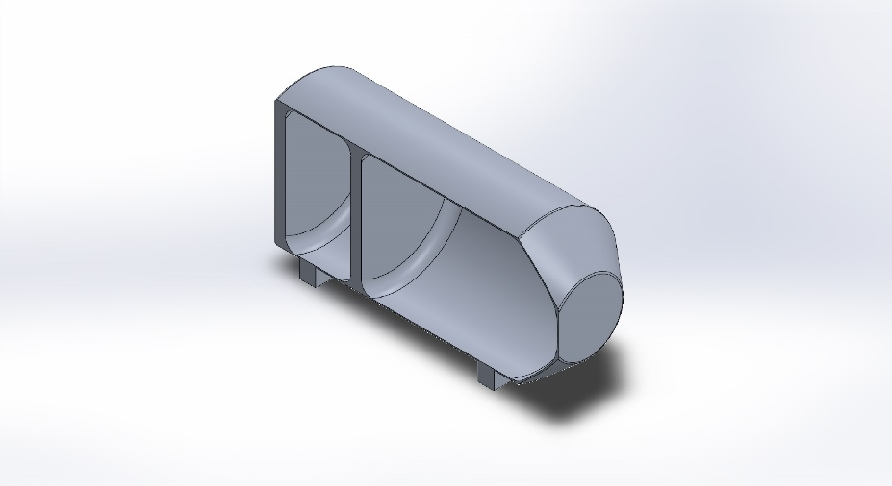
  Simulation of NASA RASC-AL Pressure Wall with Window
  Date: Friday, October 29, 2021
  Designer: Keerthi S. Gopi-Nagaruri
  Study name: SimulationXpress Study
  Analysis type: Static
  Table of Contents
  Description 1
  Assumptions 2
  Model Information 2
  Material Properties 3
  Loads and Fixtures 3
  Mesh information 4
  Study Results 6
  Conclusion 9

Description
No Data

Assumptions

Model Information

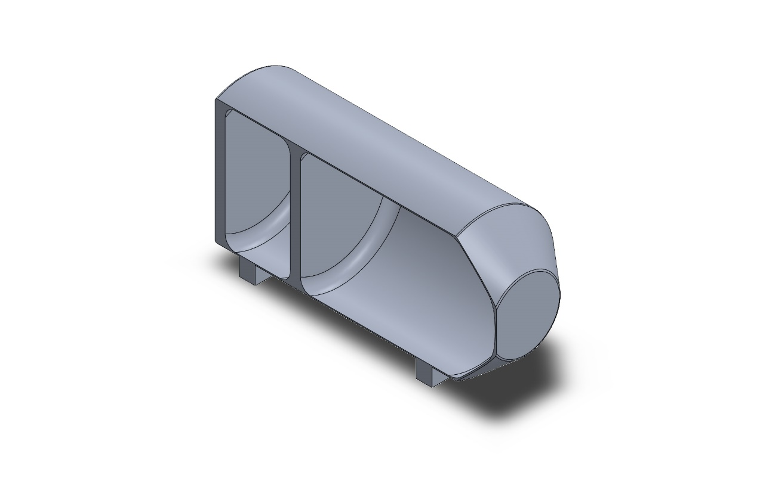
Model name: NASA RASC-AL Pressure Wall with Window
Current Configuration: Default
Solid Bodies
Document Name and Reference | Treated As | Volumetric Properties | Document Path/Date Modified
Boss-Extrude1  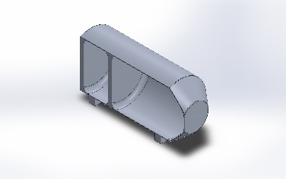 | Solid Body | Mass:20,568.5 kg  Volume:7.61796 m^3  Density:2,700 kg/m^3  Weight:201,571 N | E:\NAU\Spring 2021\CAPSTONE\Design Concepts\NASA RASC-AL Fall 2021 EDU\NASA RASC-AL Pressure Wall with Window.SLDPRT  Oct 28 03:17:19 2021

Material Properties
Model Reference | Properties | Components
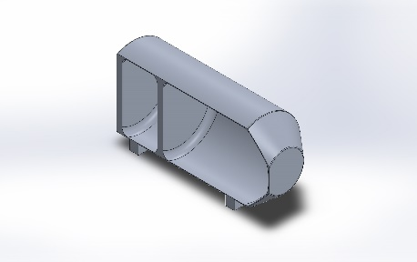 |  | SolidBody 1(Boss-Extrude1)(NASA RASC-AL Pressure Wall with Window)
  Name: | 6061-T6 (SS)
  Model type: | Linear Elastic Isotropic
  Default failure criterion: | Max von Mises Stress
  Yield strength: | 2.75e+08 N/m^2
  Tensile strength: | 3.1e+08 N/m^2

Loads and Fixtures
Fixture name | Fixture Image | Fixture Details
Fixed-1 | 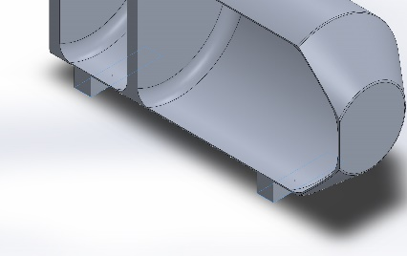
  Entities: | 2 face(s)
  Type: | Fixed Geometry

Load name | Load Image | Load Details
Pressure-1 | 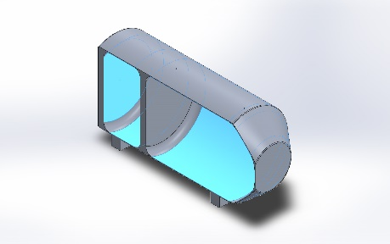
  Entities: | 4 face(s)
  Type: | Normal to selected face
  Value: | 101,300
  Units: | N/m^2

Mesh information
Mesh type | Solid Mesh
Mesher Used: | Standard mesh
Automatic Transition: | Off
Include Mesh Auto Loops: | Off
Jacobian points for High quality mesh | 16 Points
Element Size | 271.703 mm
Tolerance | 13.5852 mm
Mesh Quality | High

Mesh information - Details
Total Nodes | 15892
Total Elements | 8111
Maximum Aspect Ratio | 34.622
% of elements with Aspect Ratio < 3 | 29.8
Percentage of elements with Aspect Ratio > 10 | 51.2
Percentage of distorted elements | 0
Time to complete mesh(hh;mm;ss): | 00:00:04
Computer name: | RYAN-PC
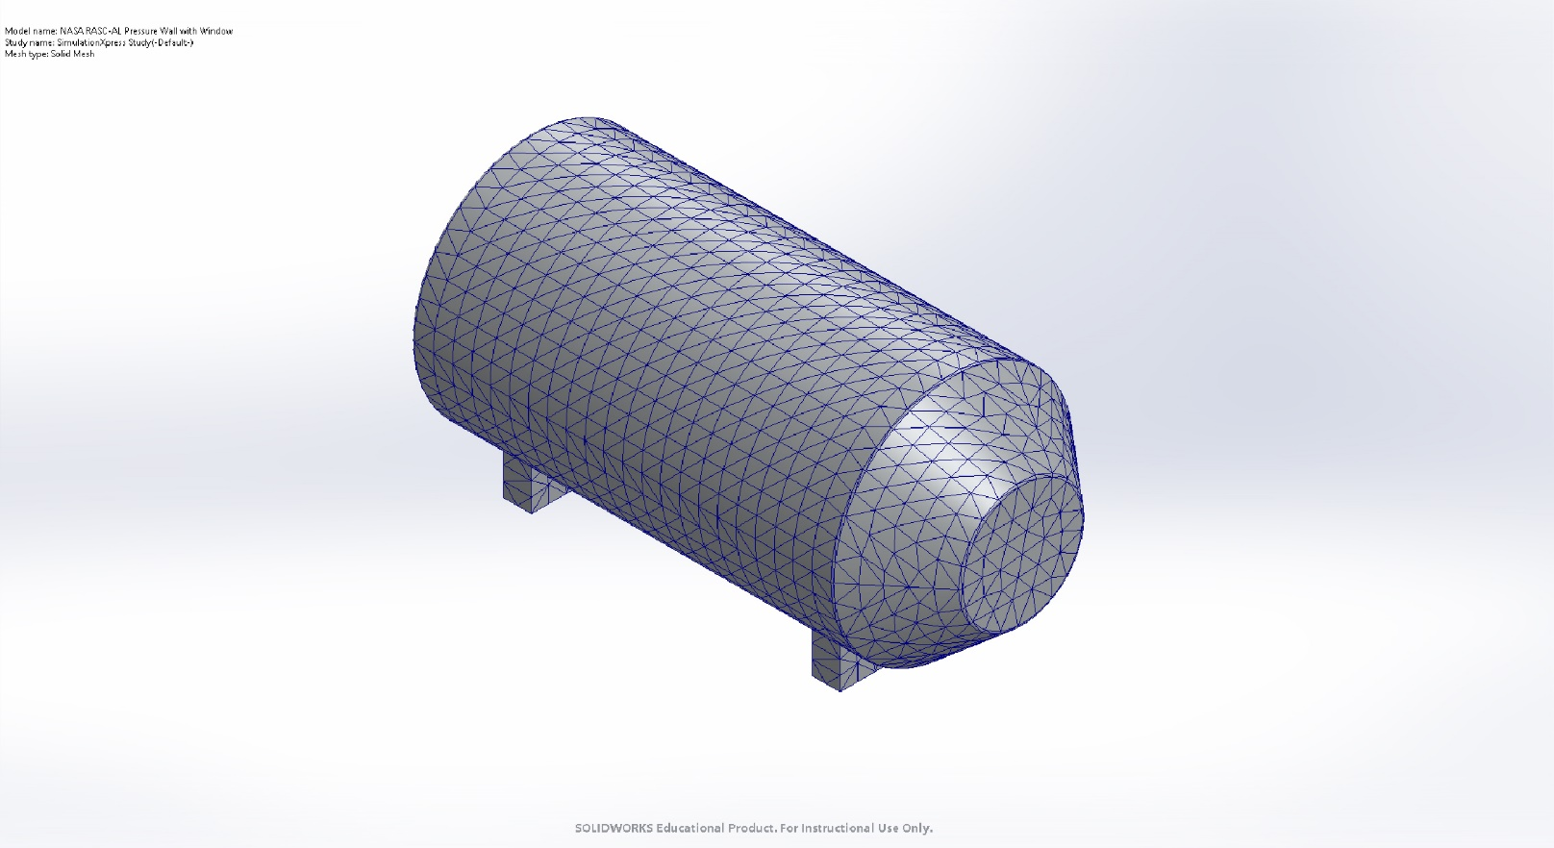

Study Results

Name | Type | Min | Max
Stress | VON: von Mises Stress | 2.549e+04N/m^2  Node: 5721 | 8.671e+06N/m^2  Node: 9990
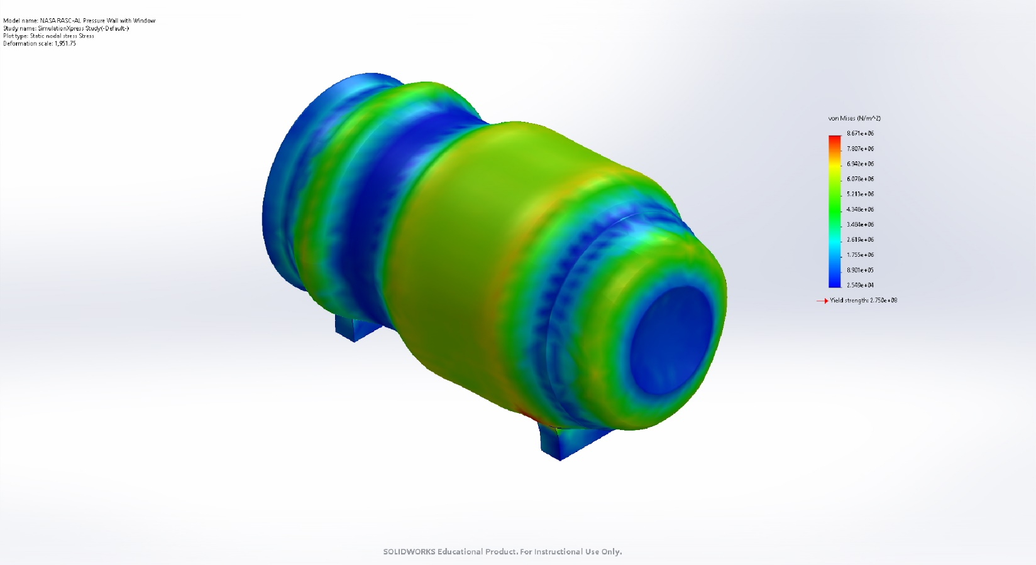
NASA RASC-AL Pressure Wall with Window-SimulationXpress Study-Stress-Stress

Name | Type | Min | Max
Displacement | URES: Resultant Displacement | 0.000e+00mm  Node: 1278 | 3.738e-01mm  Node: 775
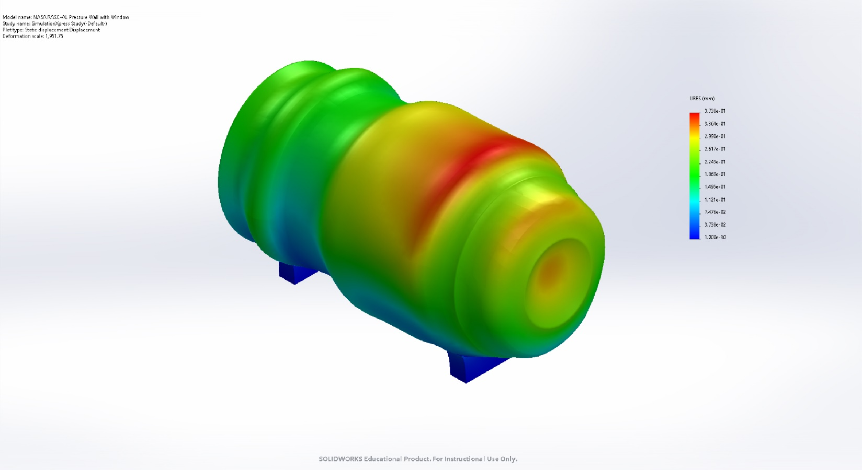
NASA RASC-AL Pressure Wall with Window-SimulationXpress Study-Displacement-Displacement

Name | Type
Deformation | Deformed shape
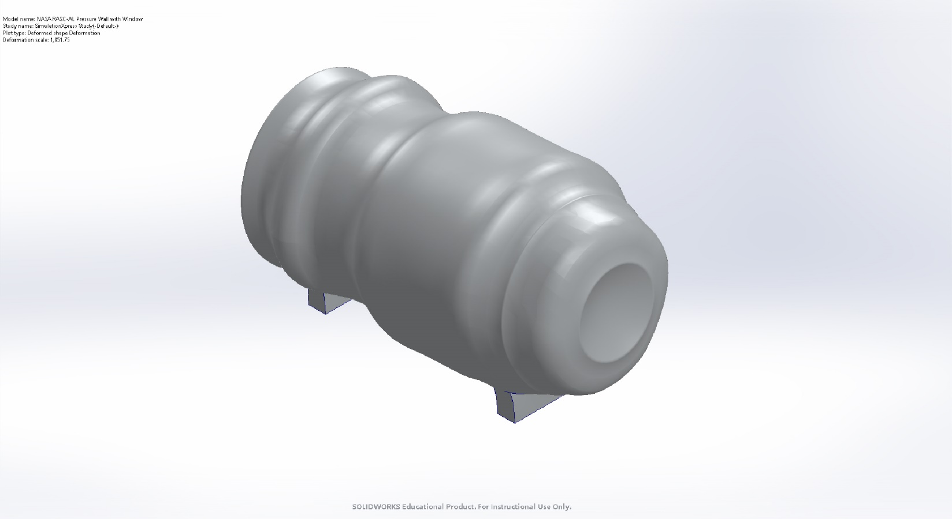
NASA RASC-AL Pressure Wall with Window-SimulationXpress Study-Displacement-Deformation

Name | Type | Min | Max
Factor of Safety | Max von Mises Stress | 3.171e+01  Node: 9990 | 1.079e+04  Node: 5721
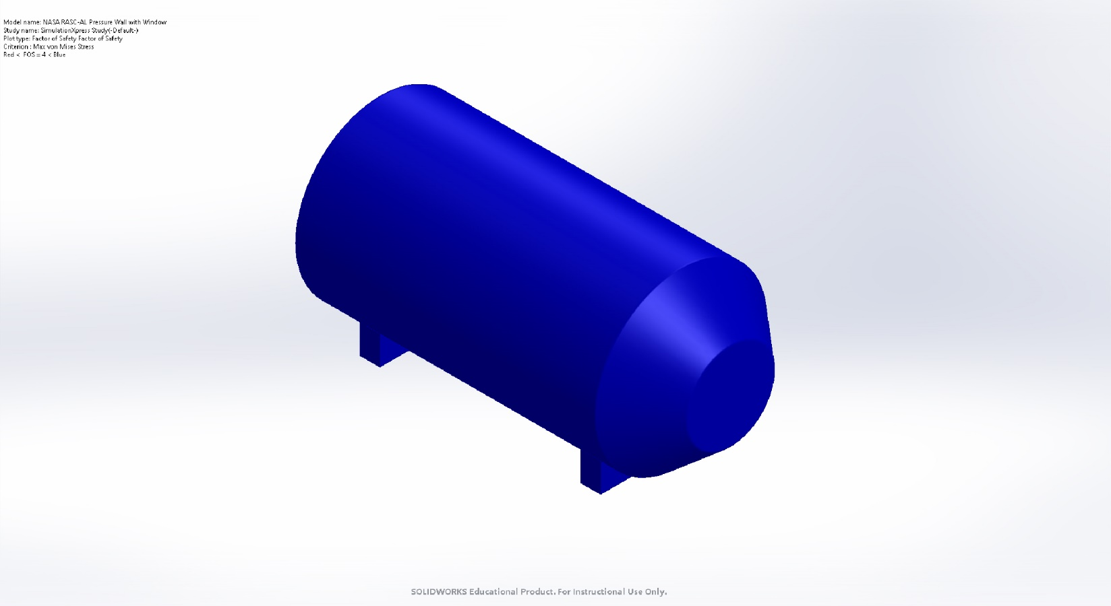
NASA RASC-AL Pressure Wall with Window-SimulationXpress Study-Factor of Safety-Factor of Safety

Conclusion

